Part 1.

|  |  |  |
| --- | --- | --- |
| Losing Interest |  |  |
|  | 10% discount | 20% discount |
| Who purchased games | 20.39% | 48.63% |
| Still playing eight weeks later | 19.23% | 21.54% |
| Total games bought (8 weeks) | 12.89% | 26.21% |
| Total hours played | 11.45% | 17.92% |
| Profit | 19.23% | 16.74% |

For the segment of customer that is losing interest, I would recommend the 20% discount. There are 28.63% more additional people purchased the game. Most games will have better user experience when it’s more popular. There is 2.21% more people who received 20% discount are still playing eight weeks later. Since there are more than double that of people who received 20% discount bought the games, 2.21% increase in retention rate is significant. The people who receive 20% discount bought more than twice as much game as the people who received a 10% discount. The 20% discounted segment also spent significantly more hours playing. Therefore, it’s obvious that the 20% discount are more effective in stimulating interest for the user who were previously losing interest to the platform. Even though the 20% discount program is slightly less profitable, I will recommend the 20% discount program.

|  |  |  |
| --- | --- | --- |
| Inactive |  |  |
|  | 10% | 20% |
| Who purchased games | -3.48% | 63.07% |
| Still playing eight weeks later | -4.07% | 4.65% |
| Total games bought (8 weeks) | -0.25% | 51.99% |
| Total hours played | -5.73% | 95.90% |
| Profit | -1.84% | -1.05% |

The 10% discount program is obviously not effective - it performed worse than the control group in all respects by small margin. The 20% discount perform significantly better than the control group with the cost of a small loss in profit. I will recommend the 20% discount program since it’s obviously effective in bringing users back to the platform.

Part2

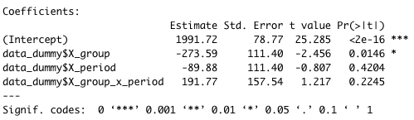

From the regression analysis, it looks like when there is promotion, the unit sales will go down by 273.59 units. However, we cannot draw statistically significant conclusion on the treatment (promotion) effect on the sales as indicated by the high p-value for the [group][period] interaction – the difference in difference. I suspect the poor result of the regression analysis might be due to omitted variable bias.

Therefore, I try to include more independent variables in my regression analysis, and found the following variables may have correlation with unit sales and therefore need to be control for:

Whether game is strategy or not (X_strategy);

Whether game is action or not(X_action);

Whether the game is expensive (price >=$30) or not (X_hi_price);

Whether the game is inexpensive (price <=$20) or not (X_lo_price);

Whether the game has been released for less than 7 weeks or not (X_lo_age);

Whether the game has been released for more than 20 weeks or not (X_hi_age);

Also, from the correlation plot below, we found that the action genre is strongly correlated with the strategy genre. Therefore, we drop the action dummy from our analysis to avoid multicollinearity problem.

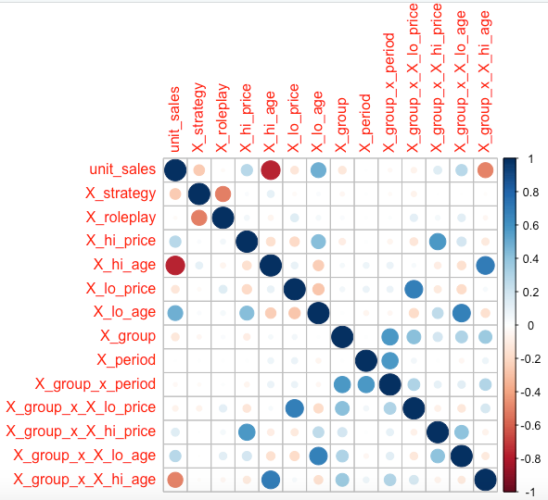

Then, I re-run the regression analysis with new independent variables.

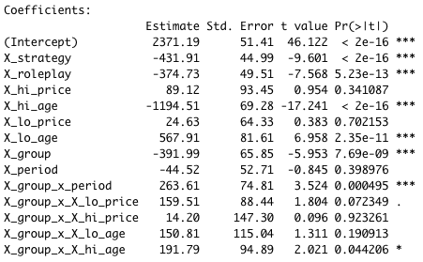

The new regressions have shown that the promotion have strong causal effect on sales as indicated with the large difference in difference (regression coefficient of [group][period]) with p-value way less than 0.05.

Our analysis also shows that the promotion has positive relationship with inexpensive games (price cheaper than $20) and does not have much impact on expensive game (price higher than $30). Even though the p-value for X_lo_price is slightly higher than our 0.05 cutoff, it’s still quite low. I decided to take it as statistically significant enough to be included.

Last but not least, the promotion has positive relationship with the games which have released for more than 20 weeks and do not have much impact on games which have been on released for less than 7 weeks.

In conclusion, I will recommend continue the promotion but focus on inexpensive games which have been released for at least 20 weeks.